Expense Tracker System

Overview
The Expense Tracker System is a simple, console-based Python application developed to help users record, manage, and monitor their daily expenses in an organized manner. The system provides a menu-driven interface that allows users to add new expense records, view all expenses, search for a specific expense using a unique Expense ID, and delete existing records. To ensure data persistence, the application uses file handling so that expense data is permanently stored and available even after the program is closed and reopened.

Problem Addressed
Tracking expenses manually using notebooks or memory can result in several issues such as data loss, incorrect calculations, lack of financial clarity, and difficulty in analyzing spending patterns. Manual methods are also time-consuming and prone to human error. This project addresses these problems by providing a basic digital solution that ensures accurate record keeping, easy access to expense data, and improved financial awareness.

Main Features
- Add Expense Record – Allows users to enter expense details including Expense ID, Category, Amount, and Date.
- View Expenses – Displays all stored expense records in a structured format.
- Search Expense by ID – Enables users to find a specific expense using its unique Expense ID.
- Delete Expense Record – Removes an existing expense entry from the system.
- Menu-driven Interface – Provides a user-friendly menu for easy navigation.
- Input Validation – Prevents incorrect or invalid user inputs.
- Data Persistence – Stores expense data permanently using file handling.

Python Concepts Used

Data Structures
- Dictionary – Used to store expense details with keys such as Expense ID, Category, Amount, and Date.
- Lists – Used to store multiple expense records efficiently.
- Dictionary of Lists Structure – Each list index represents a single expense entry across all fields.

Control Flow
- While Loop – Continuously displays the menu until the user chooses to exit.
- If / Elif / Else Statements – Handle menu options and program logic.
- For Loop – Iterates through expense records for viewing and searching operations.

Functions
- show_menu() – Displays available menu options.
- add_expense() – Adds a new expense record.
- view_expenses() – Displays all expense records.
- search_expense() – Searches for an expense using Expense ID.
- delete_expense() – Deletes an expense record.
- save_to_file() – Saves expense data to a file.
- load_from_file() – Loads stored expense data when the program starts.
- exit_program() – Safely exits the program after saving data.

Methods Used

List Methods
- append() – Adds new expense records to the list.
- pop() – Removes expense records.
- len() – Returns the total number of expense entries.

Dictionary Methods
- keys() – Accesses dictionary keys.
- values() – Accesses dictionary values.
- get() – Safely retrieves dictionary values.

String Methods
- strip() – Removes extra spaces from user input.
- title() – Formats expense category names properly.

Exception Handling
The program uses try and except blocks to handle runtime errors such as entering text instead of numbers for Expense ID or Amount. ValueError exceptions are handled to prevent program crashes. Clear and user-friendly error messages are displayed, ensuring smooth execution and better user experience.

File Handling and Libraries
- File Handling – Expense data is stored using Python’s open() function with read ("r") and write ("w") modes.
- with open() Statement – Ensures files are properly closed after operations.
- Data Persistence – Expense records are saved before exiting and loaded at startup.
- Libraries Used – Only standard Python libraries are used, with no external dependencies.

How to Run
- Open Jupyter Notebook or any Python environment.
- Open the Expense Tracker program file.
- Run all cells or execute the main program.
- Follow the on-screen menu instructions.

Input and Usage Guidelines
- Numeric Inputs – Expense ID and Amount must be numeric.
- Text Inputs – Expense Category should be entered as text.
- Menu Selection – Choose options using the corresponding menu numbers.
- Invalid Input Handling – Error messages are displayed for incorrect inputs.
- Exit Procedure – Use the exit option to safely close the program.

File and Dataset Details
- Data File Name – expenses.txt
- File Location – Stored in the same directory as the Python program.
- Stored Fields – Expense ID, Category, Amount, Date.
- File Creation – Automatically created if it does not exist.
- Data Loading – Expense data is loaded when the program starts.

Testing and Screenshots
Useful test scenarios include:
- Adding new expense records
- Viewing all expenses
- Searching for an expense by Expense ID
- Deleting an expense record
- Entering invalid inputs to test error handling
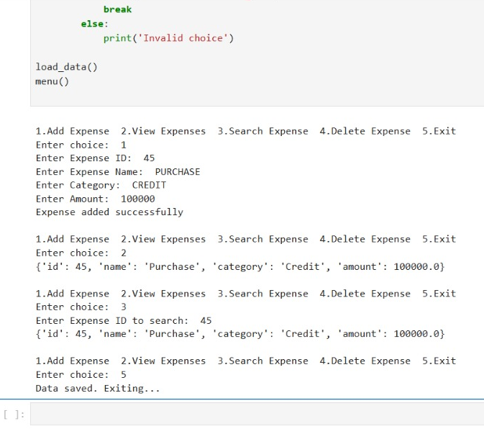

Student Details
Name: Harsha R
USN: 1BG24BA043
Course: MBA
Project: Expense Tracker System
Domain: Personal Finance Management

